Marks | Teacher’s remarks

I/ Fill in the blank( điền vào chỗ trống): 2ms
1/ I t _ ra _ _ ing . I’m W _ _. 2/ I t’s sn _ _ ing . I ‘m _ o ld.

3/It’s s _ _n _ . _ _ h _ _. 4/ h _ rr y _ _.

II/ Reorder to make sentence (sắp xếp ại thành câu). 2ms

- Up/! / hurry ________________________________
- ‘s/ raining/ It/ ./ _______________________________
- /./ I / cold/ am/ ________________________________
- Ther/wea/ ________________________________

III/ See and write( nhìn và viết): 2ms

IV/ complete the table with the given words (Điền vào chỗ trống với từ gợi ý) 2ms.

Snowing wet hot raining sunny cold weather

Weather | snowing
feelings |  |  | hot
V/ Listen and tick (nghe và đánh dấu ) 2ms.

1/ Hurry up ! It’s snowing Hurry up ! It’s raining.

2. It’s raining here It’s raining everywhere.

3. I’m wet I’m hot.

4/ I’m very very cold I’m very cold.

Scores | Teacher’s comments

- Listen and complete: (nghe và điền vào trỗ trống) – 2ms.
I’m _________________. Have ____________chicken, soup.
I’m hungry. ____________ some chicken, soup.
I’m hungry. Have some _______________, soup.
Have some chicken, _____________, soup.

2.Unscramble: ( săp xếp lại thành câu) – 2 ms.

- Am/ I/ hungry/./ ____________________________________________

- Chicken/ ./ have/ some _______________________________________

- It/ good/ ./ Mmm/ ./’s /_________________________________________

- Up/ ./ raining/ Hurry/./ It’s ___________________________________

- . / time / lunch ____________________________________________

- Noodles / some / . / Have ____________________________________

- Opus ____________________________________________________

- Hot / am / I / ./ _____________________________________________

3. Look and write ( nhìn và viết) – 2ms.
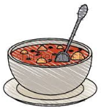
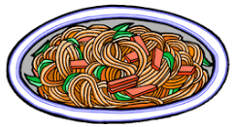

_______________ ____________ ______________ ______________
4. Match (nối) – 2ms.

1. lunch | a. I’m cold.
2. Chic | b. ken
3. It’s snowing. | c. good
4. Nood | d. time
5. It’s | e. up
6. So | f. I’m wet.
7. It’s raining. | g. les
8. It’s sunny. | h. I’m hot.

Key: 1__, 2__, 3__, 4__, 5__, 6__, 7__, 8__.

5. Complete the table with the given words (Điền vào chỗ trống với từ gợi ý) 2ms.

Snowing noodles hot raining sunny cold wet weather

Chicken lunchtime soup

Weather | snowing
feelings |  | Wet | Hot
Food |  | chicken

THE END

Marks | Teacher’s remarks

- Listen and write (nghe và viết)
That’s my _____________. No, no, no.
Yellow ________________, No, no, no.
_________ my pillow. No, no, no.
That’s my ________________ _______________.

- Fill in the blank ( điền vào chỗ trống)
a/ N __p t__ me.
b/ Th ___ t’s m __ p __ ll __ w.
c/ No ! It’s __y P __ __ __ __ w.
d/ S __ __ ! B __ Q__ __ e __.
e/ hurr___ up. It___ su___ ___y. I’m ___ ____ _____.
f/ I’m hu___ ___ ry.
g/ H___ ve some n___ ___dles.
h/ ___ ___ at’s my bl__ __ket.

- Complete, draw and color ( Hoàn thành, vẽ và tô màu)

a/ That’s my b __ ___k.

a/ That’s m__ p __ __ __ ___w.

c/ Have some ch___ck__n.

4. Reorder to make sentences or words (sắp xếp thành câu hoặc từ hoàn chỉnh)

a/ timeapn __________________________.

b/ my/ pillow/ That’s. ___________________________.

c/ my/ No !/ It’s/ blanket/ _________________________.

d/ Be/ !/ !/ Shh/ quiet. ____________________________.

5. Put the number in right picture (Điền số thích hợp vào tranh)

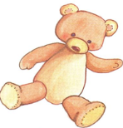

1. noodles | 2. be quiet ! | 3. It’s snowing | 4. chicken
5. pillow | 6. It’s raining | 7. blanket | 8. bear

6. Look at the picture and complete (Quan sát tranh và hoàn thành câu)
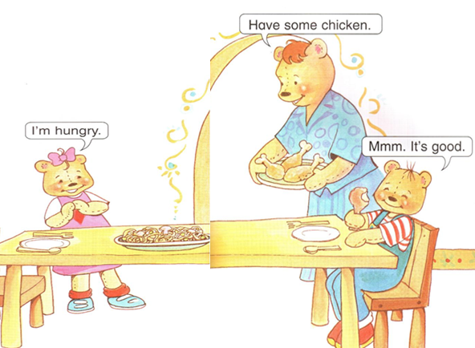

Marks | Teacher’s remarks

- Listen and write (nghe và viết):
a.___e’s a ______________officer. c.________ a ___________.
b. ______’s a doc_________. d. _______’s a far_________.

2. Fill in the blank( điền vào chỗ trống)
a/ In t__ ___ n.
b/ R __ ___ L __ gh __. S ___ ___
c/ Gr __ __ n li __ __ t. G __.
d/ She __ a P __ l _ ic __ off __ __er.
e/ H __’s __ d _ ct __ r.

3. Match and write ( nối và viết)
P __ __ __ __ __ o __ __ __ __ __ __

F __ __ __ __ __

D __ __ __ __ __

4. Unscramble (sắp xếp lại):
- Town/ in. __________________________________.
- Police/ She’s/ a/ officer. _________________________________.
- ‘s/ doctor/ He/ a. ______________________________________.
- He/ a/ ‘s/ farmer. ___________________________________.

5. Translate into English ( dịch sang Tiếng Anh).

a. Cô là 1 cô công an____________________________
b. Anh là 1 chú công an ___________________________
c. Ông là 1 nông dân____________________________
d. Bà là 1 nông dân______________________________

6. Look and complete the sentences (quan sát tranh và hoàn thành câu)
1 | ______________’s a police officer.
2 | ______________’s a doctor.
3 | ______________’s a farmer.
4 | She’s a __________________________________.

Marks | Teacher’s remarks

- Listen and write .
a/Ca ……….. b/I w…….. chips
c/ Ice ………………. d/ No. Not ……………
- Let’s complete.
a/ I ………………….. candy.
b/ I w ……………… Ch……..
c/ …… want ice ……………………….
d/ No, …………………….. Not ……………………

- Reorder to make sentence.
- /./ candy/ want/ I/
________________________________
- Ice/ I / want/ cream/./
__________________________________
- Today/ ./ Not/ No
__________________________________
- She/’s/ police/ a/ officer /./
__________________________________
- Be/!/ quiet/ Shh/!/
____________________________________
- Light/ ./ red/ stop
_____________________________________

- Look and write.

a/ I want _______________________

b/ _____________________________

c/ He’s a ______________________

- Complete the table (hoàn thành bảng sau).
Raining chips farmer sunny hot doctor wet cold
Weather soup police officer chicken I snowing

Weather |  | snowing
Feelings |  |  | wet
Food |  | chips
Job | doctor

Marks | Teacher’s remarks

- Listen and complete – 2ms (nghe và hoàn thành câu)

1. Play w__ __h __ __. __ __. Let’s sw__ ng.
2. O __. __et’s __ __ __.
3. I w__ __t ca__d__.
4. H__ ve s__me chic__ __ __.

- Fill in the blank( điền vào chỗ trống)

a/ __l a __ t __ __ __.
b/ __ __. L __ ___ ‘s s __ __ __ g.
c/ __ __. L __ ___ ‘s s __ __ __ e.
d/ __ __. L __ ___ ‘s r __ ___.
e/ It__ rain__ __g. I’m __ __t.
f/ N__, Ben__ __. __ __ __ today.
g/ That’s __ __ pill__w.
h/ __he’s a poli__e o__ __icer

- Look and write ( nhìn và viết)

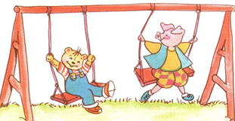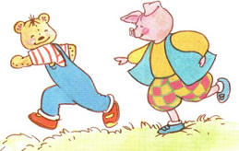

a/ ___________________________ b/ __________________________

4. Match (nối):
Play let’s run.

Ok with me

Let’ slide

It’s sunny Stop !

I’m hungry No. Not today

That’s my blanket I’m hot

I want ice cream Have some noodles

Red light No. It’s my blanket
5. Unscramble (sắp xếp lại).

a. /./ OK/ swing/ Let/ ‘s/ _____________________________________.

b. time/./ play ____________________________________.

c. me/./ play/ with ____________________________________.

d. police/./ he/’s/ officer/a ____________________________________.

e. hungry/ . / am / I/ ____________________________________

f. Have / apples / some /. / ____________________________________

g. farmer / . / He / is/ a / ______________________________________

h. everywhere / is / snowing /. / It/ ______________________________

THE END

