**TEST 2**

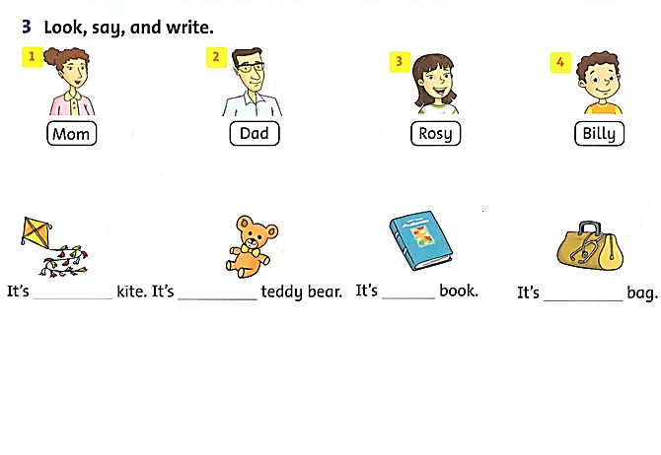**I/ Look and write.**

**II/ Match and write.**

|  |  |  |  |  |
| --- | --- | --- | --- | --- |
|  |  |  |  | **Answer** |
| 1. | What do you do? | a. | Yes, he is. | 1. _____ |
| 2. | What color is it? | b. | I’m fine, thanks. | 1. _____ |
| 3. | Is this your bike? | c. | No, it isn’t. | 1. _____ |
| 4. | How are you? | d. | I’m a student. | 1. _____ |
| 5. | Is he your teacher? | e. | It’s blue. | 1. _____ |

|  |  |  |  |
| --- | --- | --- | --- |
| **III/ Write.** | **Is he Is she** |  | |
| __________ a doctor? | | | __________ a teacher? |
| __________ a student? | | | __________ a pilot? |

**IV/ Read and circle.**

|  |  |  |  |
| --- | --- | --- | --- |
| Image result for bird | ***Is this a bird?*** | Yes, it is. | No, it isn’t. |
| Image result for book | ***Is it a book?*** | Yes, it is. | No, it isn’t. |
| Image result for doctor | ***Is he a doctor?*** | Yes, he is. | No, he isn’t. |
| Image result for student | ***Is she a student?*** | Yes, she is. | No, she isn’t. |
| Image result for lion | ***Is it a lion?*** | Yes, it is. | No, it isn’t. |

|  |  |  |
| --- | --- | --- |
| Image result for fingers clipart | **­__­­­­_ ­­­___ ­­­­___ ___ ­­­­___ ­­­­___ ___ ­­­­** | **s n f**  **r g e i** |
| Image result for ink bottle | **___ ­­­­___ ___ ­­­­­­** | **i k**  **n** |
| Image result for teacher | **___ ­­­­___ ___ ­­­­___ ­­­­___ ___ ­­­­___ ­­­­** | **a e h**  **t e c r** |
| Image result for teddy bear | **___ ­­­­___ ___ ­­­­___ ­­­­___ ___ ­­­­___ ­­­­___ ___ ­­­­** | **t r a e b**  **d e y d** |
| Image result for father | **___­­­­ ­­­___ ­­­­___ ___ ­­­­___ ­­­___ ­­­** | **e h a**  **f t r** |

**V/ Look at the pictures. Look at the letters. Write the words.**

**VII/ Order the words.**

1. ball?/ the/ is/ Where 🡪 _______________________________________________

2. her/ Are/ socks?/ these/ 🡪 _______________________________________________

3. dress/ Rosy’s/ blue./ is 🡪 _______________________________________________

4. nose./ is/ This/ my 🡪 _______________________________________________

5. under/ seesaw./ It’s/ the 🡪 _______________________________________________

**VIII/ Write. name toys brown you eight teddy bear**

Hello.

My _________ is Nga.

I am ________ years old. I like _________.

My favorite toy is a __________________. It’s __________.

How about ________? What’s your favorite toy?