Name:_________________ Class:_____ School:_____________________
Ôn tập học kì 1 (2020-2021)
I) Speaking ( Nói) Answer: ( Đáp lại)
1.Good morning (chào buổi sáng ) →………………………………………………..………
2.How are you ?(Bạn có khỏe không?)→ ……………………………………………………
3.What’s your name ?(Tên của bạn là gì ?)→………………………………………………
4.How do you spell your name?(Bạn đánh vần tên như thế nào ?)→ …………………….……
5.How old are you ?(Bạn bao nhiêu tuổi ?)→ ………………………………………………
6.What class are you in?(Bạn học lớp gì?) → ………………………………………………
7.What is the name of your school?(tên trường bạn là gì)→ ………………………..…………..
8.What is this ? (Cái gì đây ?)→ ……………………………………… 
9.what is that ? (Cái gì kia ? ) → ………………………………………….… 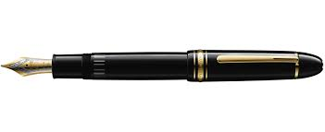
10.what are these?(Những cái gì đây ? → …………………………………..… 
11.what are those ?(Những cái gì kia ?)→……………………….…………..… 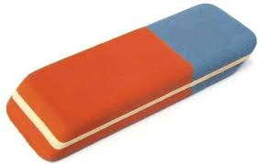
12. who is this ? (Ai đây ? ) → ………………………………………… 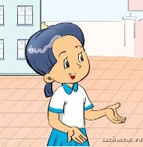
13.who is that ? (Ai kia ? ) → ………………………………………………… 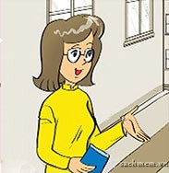
14. Who are they? (họ là ai?) →.....................................................................
15. Is that Mr Loc? (Kia có phải thầy Lộc không ? ) → …………………… × 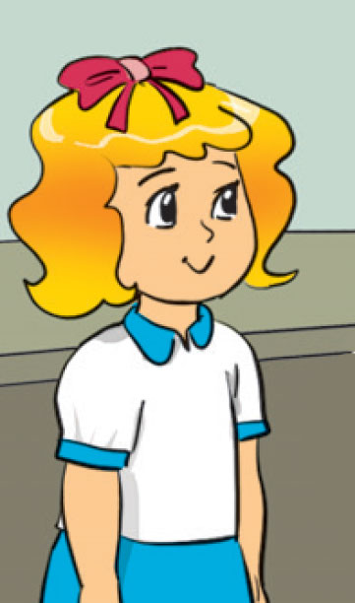
16. Is this your schoolbag?( Đây có phải cặp sách của bạn ko?)→ ……..………… √ 
17.Are these your books?(Đây có phải những quyển sách của bạn ko?)→ …………........ × 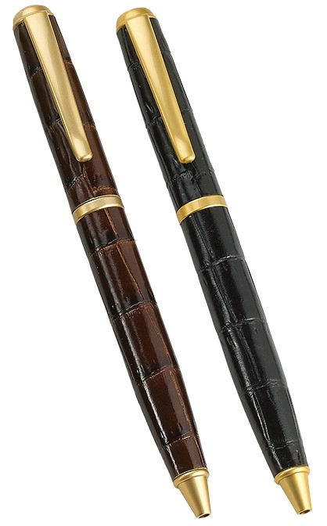
18.Are those your rulers?(Kia có phải những cái thước của bạn ko?)→ …………........√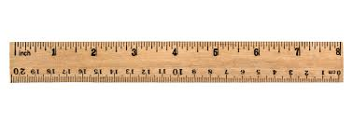
19.what colour is it ?(Nó màu gì?)→ …………………………………………  (đỏ)
20.what colour are they ? (chúng màu gì ?) → ……………………………… 
21. what colour is your pen ? (bút của bạn màu gì)-……………………………… 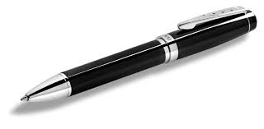
22.what colour are your rulers?(Những cái thước màu gì?)-…………...............… (nâu)
23.May I come in ? (Tôi có thể vào không ? ) →√……………………..................……
24.May I go out ? (Tôi có thể ra ngoài không ? )→× …………………………………
25. Is your classroom big ?(Lớp của bạn to không?) √→ …………………………………...
26. Is your school new ?(Trường của bạn mới không?)→ ×…………………………………...
27. Are they your friends ?(Họ là những người bạn của bạn phải không? )→√ ………………
28. Are they your friends ?(Họ là những người bạn của bạn phải không? )→ × ………………
29. Is she your friend (cô ấy là người bạn của bạn phải không? ) →√………………………..
30. Is he your teacher ( Anh ấy là giáo viên của bạn phải không? )→ ×……………………..
31.what do you do at breaktime?(Bạn làm gì giờ ra chơi?)-…………………..…………....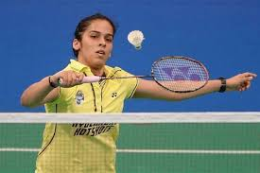
32.what do they do at breaktime?(Họ làm gì giờ ra chơi?)-…………………..…………...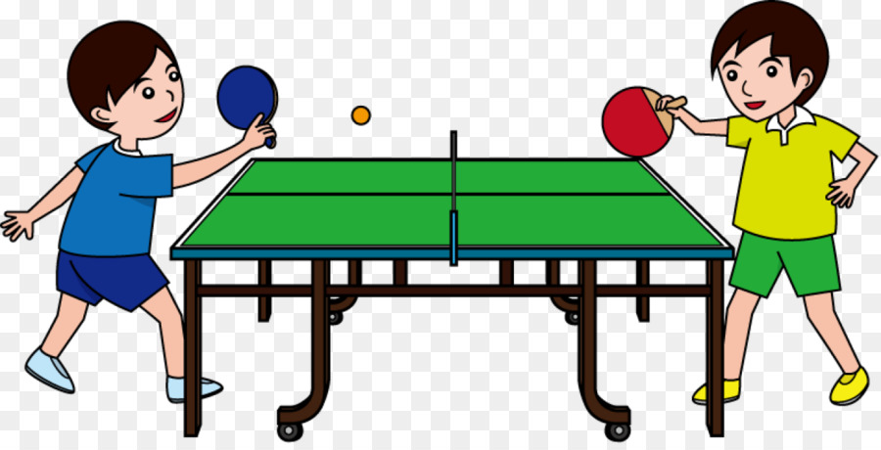
33.what do Phong and Quan do at breaktime? -…………………..………………...…. 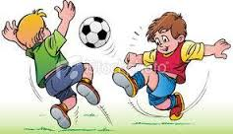
(Phong và Quân làm gì giờ ra chơi ?)
34. Do you like hide-and-seek? (Bạn có thích trò trốn tìm không?) →×………..……………
35. Do you like skipping? (Bạn có thích trò nhảy dây không?) → √ ………..……………
36.Do Linda and Mai like skating?(Bạn Linda và Mai có thích trượt ba tin ko?)√→…….......…
37.Do they like blindman’s bluff ?(Họ có thích bịt mắt bắt dê ko?)→×………..……...………
38.Let’s play chess.( Nào chúng ta hãy chơi cờ) →.....................................................................
39. Nice to meet you ( Rất vui được gặp bạn ) →……………………..........….……………….
40. Goodbye (tạm biệt )→…………………………………………………..........................
I ) Nối ( matching) A - B
a)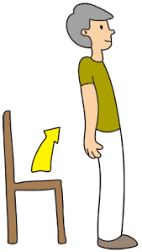  b)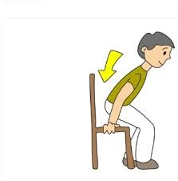  c) 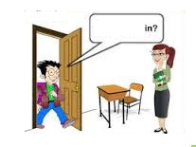  d) 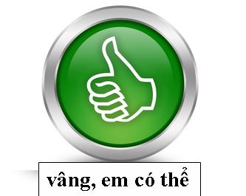  u)  z)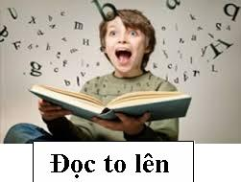  r)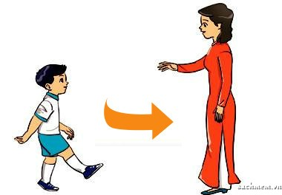 | 1.Sit down please.  2. Stand up please  3.May I come in?  4. May I go out?  5. No you can’t  6. Yes you can (sure)  7. May I speak ?  8. May I write ? 9.Open your book please  10.Close your book please  11. May I ask a question?  12.Come here  13.Read aloud  14. Don’t talk | h) 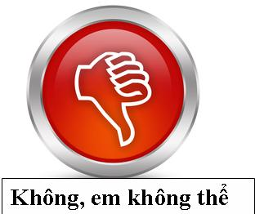  i) 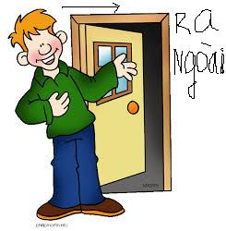  j)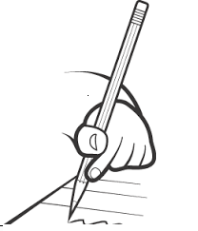  k) 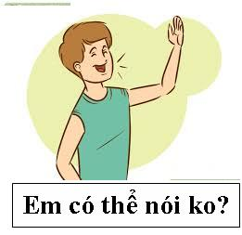  l)  v)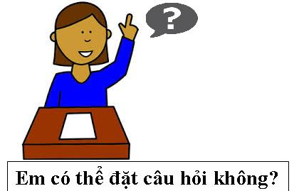  s)  | II)Fill in (Điền từ thích hợp) 1. Stand __________ please 2. ________I speak ?  3. Sit______________ please 4. May ___________ write? 5.May I _______________ out ?  6. √ Yes you _________ 7.May I ___________in ? 8. No _____ __________  9.May I ______ a question ? 10. × ____you can 11.May I _______ aloud ? 12. ____ you can’t.  13.May ______ sing a song?  14. Open your book _________
III) Nối A → B
1.Hello  2.How are you ?  3.What’s your name ?  4.How do you spell your name?  5.How old are you ?  6.what colour is it ?  7.May I come in ? √  8.May I go out ? ×  9. Nice to meet you  10. Goodbye  11. Is your library big?  12. what is this?  13. what are these?  14. what colour is your pen?  15.what colour are your books?  16.what do you do at breaktime?  17. Do you like skipping?  18.Are they your friends ?  19. what class are you in?  20.what’sthe name of yourschool?  21.Do An and Ha like basketball?  22.what do they do at breaktime? | a)My name is Lan  b)Hi  c)I am fine,thank you  d)It is pink  e)It’s L-A-N  f)Yes you can  g)I am seven years old  h)Nice to meet you too  i)No,it isn’t.It’s small  j)No, you can’t  k)Bye, see you later  l)They are my books  m)It’s a pencil case.  n)They are red  o)My pen is blue  p)Yes they are  r)Yes I do  s)I play chess  t)It’s Hue primaryschool  w) yes they do  z)theyplayblindman’sbluff  v) I’m in class 3A | 1. how old ………….. you?  2.I am …………. years old(7)  3. what………. is your pen?It’s blue  4.they are ten ………….old  5. how do you……… your name ?  6-…… I go out ? Yes you……….  7.what colour…..your cats?............red  8.what….yourname?My name….Ha  9. what ……... her name?  10. Her name……. Linda  11.Let’s ……chess- .…. let’s play it  12.My friends ……..… An and Ba  13. This……. my pen  14.These …..…. my books  15. That……. my pencil  16.those ……. my rulers  17.Is that your pen?→yes…….….  18.Are these your rulers?no……..…  19.Do you ……..skipping?Yes I….  20.what…….you do ….breaktime?  21. I ……….. badminton.  22.Do they like chess?No …. …..
IV) Sắp xếp: 1.spell/ how/ do/ your/you/?/ name→………………………………….………..
2.your /classroom /big / Is /? is/ it / yes →……………………………………………..…….….
3 . my / notebook / is/ That . →………………………………………………………………… 4. your/ pens/Are/ those/ no/aren’t/they/?→……………………………………………..………. 5 .my / rubber/ is/ This. →……………………………………………………………………… 6. my/ pencils/ are/ these/ →……………………………………………………………………. 7.do / you / do / at/ what/ breaktime ? →………………………………………...……………… 8.play/ hide / seek/ and/ I →…………………………………………………………………….. 9.like/ Do/ you/blindman’s/bluff ?I/do/yes→…………………………………………...…….… 10. your/ books/ are/ colour/ what/? →…………………………………………………………. 11. your/ school bag/ is/ colour/ what/?→……………………………………………………….
12. play/badminton/Let’s →……………………………………………………………….……..
PHIẾU KIỂM TRA ĐỊNH KÌ LẦN 1. NĂM HỌC: 2019 – 2020
ĐỀ 1. Môn: Tiếng Anh. Lớp 3 ( Chương trinh tiếng Anh 10 năm) - Thời gian:40phut

Họ và tên:………………………… Lớp:………. Trường:……………………
Ex1.Listen and tick. (1.0point)
1. a | b  | 3. a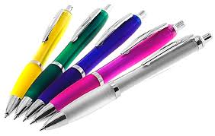 | b 
2. a | b 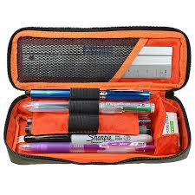 | 4. a 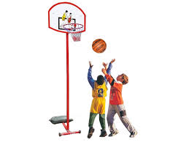 | b 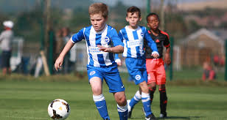
Ex2. Listen and number (1-5)the pictures. The first picture is done for you. ( 1ms)
Example: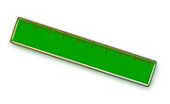 | 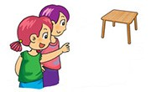  B. | C. 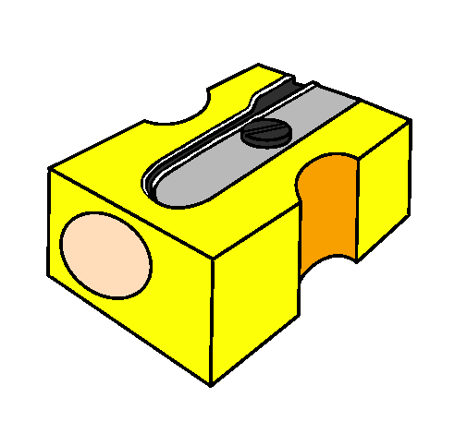
  A.
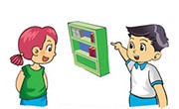  D. | 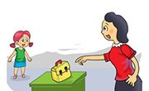  E. | 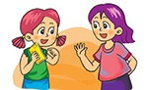  F.
EX3.Look and read. Tick () or cross (X) the box. ( 1ms)
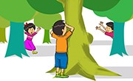
1. May I go out ? 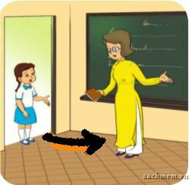 2.This is my classroom.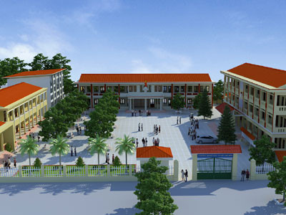 3.These are my school things. 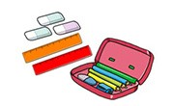
4.-The pen is orange. 5. - They play hide-and-seek at break time.
Ex4:Choose the best answer( 1ms) Ví dụ: 0.I play___  A.basketball B.badminton C. chess
1.These are my_____________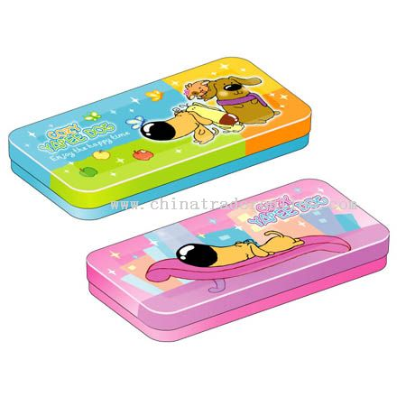 A. notebooks B. pencil cases C. rulers
2.I play ____________________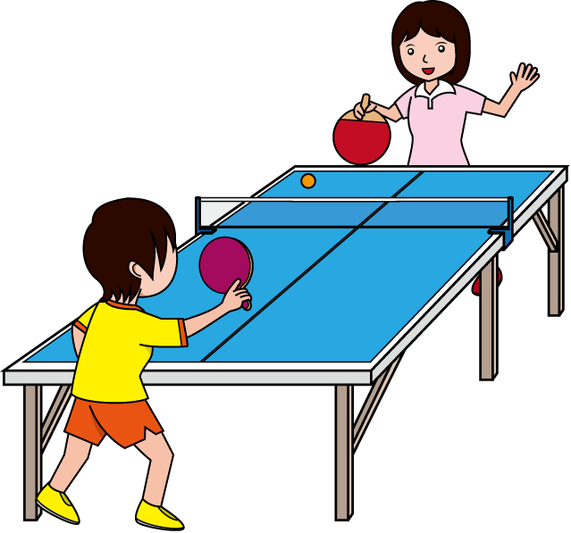 A. table tennis B. football C. chess
3. Do you like____________?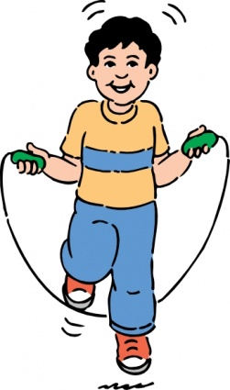 A. hide- and -seek B. skating C. skipping
4.What colour is your ____ ? It’s___ A. schoolbag /white B. pencil /pink C. bags /blue
5.What colour are your ____ ?They’re___ A. pen /black B. pens /black C rulers /blue
Ex5. Read and complete. There is one example. (2 mark)
name | pens | book | are | black | my

Mai: Hello ,My(0) name is Mai→Tony: Hello!Nice to meet you.(1)_____ name is Tony.What is this?
Mai: It’s my (2)__________ → Tony: what (3)_______these?
Mai:they are my (4) _________.→Tony: what colour are your pens? Mai: they are (5)____________
Ex6.Write: 0.name’s/Phong/My →My name’s Phong.
1.is / name /your/ what /?→………………….…….................…………………………………………..
2. I / football / at / breaktime/ play→.................... .............
Ex7. SPEAKING Match each question with a suitable answer. (1mark) Answer: . 1.How do you spell your name? A. My name is Peter 1:______
2. How are you? B. I'm eight years old. 2:______
3. What's your name? C. P- H- O- N-G. 3:______
4. How old are you? D. yes I do 4:______ . 5.What do you do at break time ? E. I’m fine. thank you 5:______ . 6.Do you like hide and seek? F . I play chess 6:______ . 7.Is this your pen? G. yes they are 7:______ . 8.Are these your books? H. No it isn’t 8:______ . 9.what colour is your pencil? I. they’re brown 9:______ . . 10.what colour are your rubbers?____ K.It’s blue 10:______

ĐỀ 2. Name:______________ Class:________________ School:___________________
I)LISTENING: Ex1: Listen and tick.(p4-unit10) Ex2: Listen and number (p4.unit6).
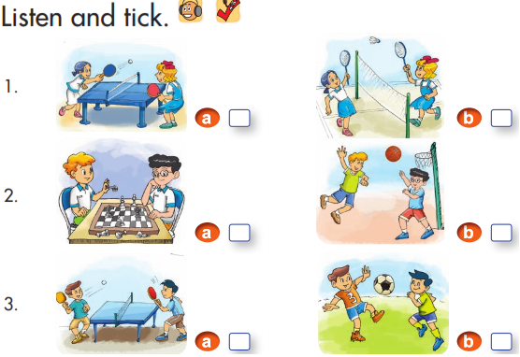 | 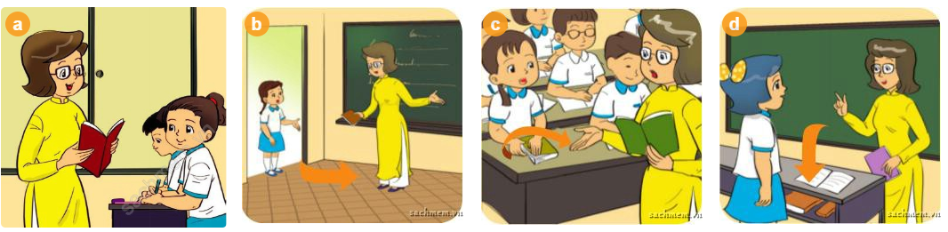  2. A____ B_____ C_____ D_____
Ex3.Listen and write.(2marks): A.1.May I ________ in? 2. Sit __________ , please.
B.1.It is my___________. 2. My favourite colour is _______ II)READING Ex4: Look and read. Tick () or cross (X) the box (1m)
0.the playground is large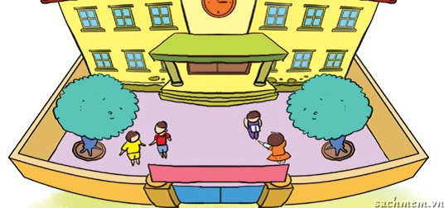 | X | 1. These are rulers. 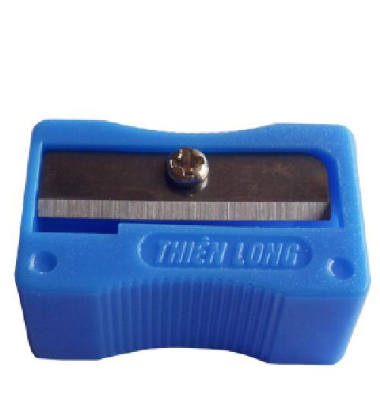
2. This is a school bag. |  | 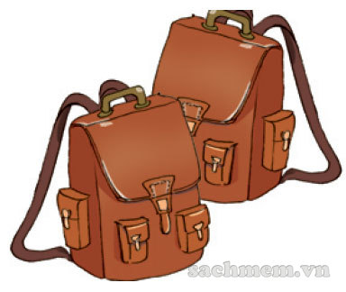3. These are my schoolbags.
4.I play hide-and-seek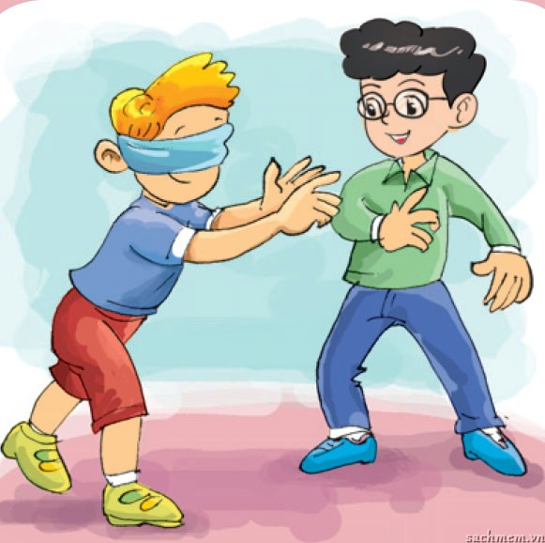 |  | 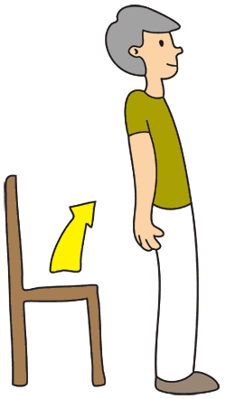 5. Don’t talk!

Ex5. Read and write :  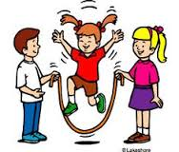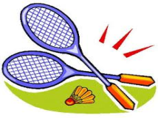 | Ex6. Tick: yes /no  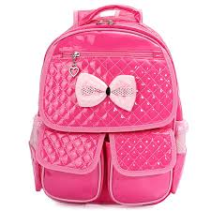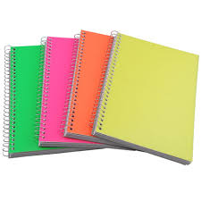
  0. Close your book , please.
  1.I like __________________.
  2.I like playing _____________.
  3.This is my ______________
  4.These are my _____________
  5.It’s a _________________
   |  | yes | No
  1. This is a pen.
  2. She is ten years old .
  3.Is it a school bag?Yes,it is
  4. These are my rulers.

Ex7: Match the questions in column A with the answers in column B. (1 mark)
A | B | Answer
1. May I ask a question, Miss Hien?  2. What colour is your rubber?  3. What colour are your pencils?  4.What do you do at break time? 5. Do you like skating? | a. They’re black and green.  b. I play basketball.  c. It’s brown.  d.No I don’t  e.Yes, you can. | 1 ___  2 ___  3___  4 ___  5___
Ex8: Complete the sentences. ( 1 mark)
break time | chess | These | play | and
Hello. My name is Tung. (1)______________ are my friends, Nam, Nga, Linda, Tony and Linh. At (2)_____________, we play different games (3)____________ sports. Nam and I play (4)__________. Nga and Linh play table tennis. Linda and Tony (5)________ badminton.
Ex9: Reorder these words to make complete these sentences. (1 mark)
1.are/ my/ school bags./ Those →……………………………………………………….…….
2.bluff/ like/ Do/ blind/ you/ man’s/ ? → …………………………………….……………….
3.do/you/what/do/breaktime/at?→…………………………………………………………….
4.playground/the/small/is. →………………………………………………………….………
PART II.READING AND WRITING .Task 1.Look and read. Tick (√) or cross (×) the box.(1mark)
1. May I go out ? □ | 2. May I come in ? 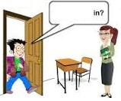□. | 3.she is ten years old.  Linda – 9 . □
4.This is my library.  .□ | 5.These are my school things .□ | 6.He is eight years old.  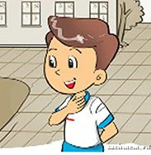 Nam-8 . □
7.The pen is orange.□ | 8.They play hide and seek. 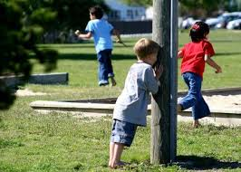 . □ | 9.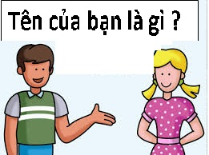how are you? □
10.That is a pencilcase. □  . | 11.I like skating. □ | 12. how old are you? 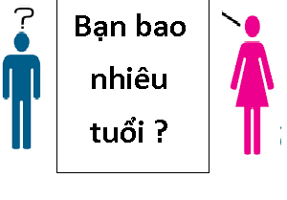□
13. This is Mr Loc .□ | 14.Hello.My name’s Mai.  .□ | 15.Goodbye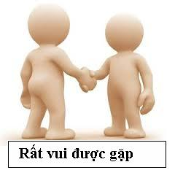□
16.This is a book □ | 17.they like skipping.□ | 18.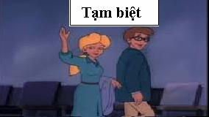 Hello. □
19.This pen is black.□ | 20.They play blindman’s bluff. 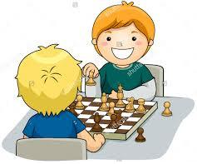□ | 21.Nice to meet you,too  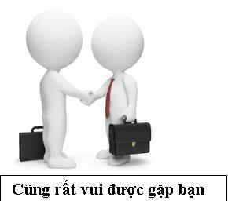
22.Stand up please.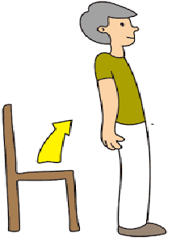 □ | 23.Be quiet □ | 24.May I speak? □
25.Open your book. □ | 26. yes you can□ | 27.That’s the computer room  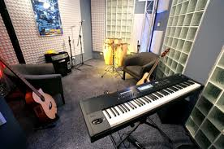□
Task 2: 28.Is this your schoolbag? - _______ A.yes this is B. yes it is C.yes they are
29. Are these your rulers? - _______ A.yes this is B. yes it is C.yes they are
30.Is that your ______? A. book B. pencils C.pencil sharpeners
31.Are those your ______? A.rubber B. notebook C.pencilcases
32.___ this your desk? A. is B.are C.am 33.___ those your rulers ? A. is B.are C.am
34.what do you do at breaktime? A. I play basketball. B.They play chess C.you play football
35. Do you like ______ ? A. skip B. skiping C.skipping
36.Do Phong and Quan like hide and seek? A. yes they do B. yes you can D. yes I do
37.________? No I don’t . A. Do you like skating? B.May I come in? C.Is that Tom?
38.__________? No you can’t . A. Do you like skating? B.May I come in? C.Is that Tom?
39.__________? No it isn’t. A. Do you like skating? B.May I come in? C.Is that Tom?
40.Are they your . yes they are. A. name B. friend C. friends
41.Who is that ? -It Mai. A. are B. am C.is 42. Sit______ , please. A. up B. down C. to
43.Stand ,please. A. up B. down C.to 44.This my school. It’s small. A. are B. am C. is
45. my school library. It’s big. A. This is B. He is C. She is
46. my book. It’s small. A. That is B. He is C. She is
47. What__ the name of your school? -It’s Thang Long primary School. A. is B. are C. am
48. Is the gym large ? - No, . A. it isn’t B. he isn’t C.It is
49.Do you like _____hide and seek? - No I don’t . A. play B. plays C. playing
50. Is your school small ? –No, it It’s big A. isn’t B. is C. aren’t
a) 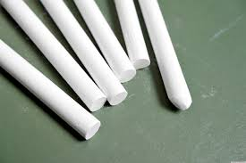  b)  c)  d) 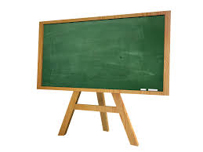  e) 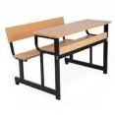  f) 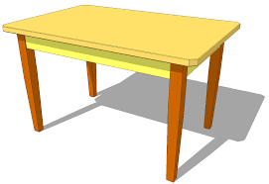  g) | 1.pen :  2.pencil:  3.book:  4.note book :  5.ruler :  6.eraser = rubber:  7.board  8.chair:  9.chalk:  10.desk  11.pencil case=penbox  12.pencil sharpener:  13.school bag= bag:  14.table: | h) 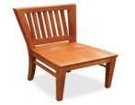  i) 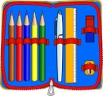  j)  k)  l)   m)  n) 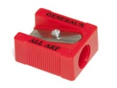 | 1.Điền:a/an1This is .....pen 2.that is… book  3. it is …….. eraser. 4. this is …….. ruler.  5. that is……. orange. 6. it’s ……….. book  2.Gạch chân lỗi sai và sửa lại. 1.Is this a pen? Yes they is→_______ 2.Is those lamps?No they aren’t→_____ 3. Are these pens? Yes it are →________ 4.Are those your desk?yes they are→_____ 5. Those are glues? Yes they are→_______ 6. Are that desks ? No they aren’t→______ 7.Are these your chalks?Yes they is→_____ 8. Are this rulers ?yes they are →_______ 9.Is your gym new ? No it is →_________ 10.Are they your friends?yes it is→_______ 11.who do you do at breaktime? →_______ 12. Do they like play chess? →________ 13.Let’s playing football. →__________
Ex1. Match A→ B
Ex2. 1. Close your book, . A. thanks B. please C. down
2. Open book, please. A. its B. your C. out
3. May I go ? A. out B. in C. to 4. May I come ? A. out B. in C. to
5. What do you do ____breaktime? - I play chess. A. in B. out C. at
6. I come in? - yes you can A. How B. May C. am
Ex3.. Trả lời câu hỏi: 1. what colour is your book? – it’s………………… ( đen )
2. what colour are your pens? – they are……………………………… ( trắng )
3. what …………..is your pencil? - ………………………………… ( đỏ )
4. what colour …….. your rulers? - ………………………………………… ( vàng )
5. -……………. colour is your rubber ? - ………………………………… ( tím)
6. what colour ………. Your schoolbags? - …………………………… ( hồng) 
7 -………….colour is your pencil case ? - …………………………… (xanh lá cây)
8. what colour ………your desks ? - ………………………………… ( nâu )
Ex4. Điền từ: 1.How old ………….. you? - I am …………. years old(7)
2. …………. old are they? -they are………... years old(10)
3.how ………….. is she ? -she …… ………. years old (9)
4.how old …….. Tom ?He ………six………...……..old.
5.what ………your name? My name…… Ha. 6. what ……... her name? Her name……. Linda
7.what…….. their names? Their names ……..… An and Ba
8.This…….my pen. 9.These ..……. my books. 10.That……. my pencil 11.Those …….. my rulers. 12.Is that your pen?→yes…….………….. 13.Are these your rulers ? No ……… ………..…
14.Do you ……...skipping ?Yes I …... 15.what …….you do ..……breaktime ?I ……….. badminton.
17.what…….. Lan and Mai do at……………………………..? → ……….. …………… chess
18.Do they like chess? No ……….. …………….. 19.Do they like skipping? No …… ……..…
Ex4. Complete the sentences. ( 1 mark)
breaktime - chess - are - play - and
Hello. My name is Lan.These(1) ______ my friends, Nam, Nga, Linda, Tony and Linh.
At(2)_____________, we play different games (3)____________ sports. Nam and I play (4)__________. Nga and Linh play table tennis. Linda and Tony (5)________ football.
Ex5.: Reorder these words to make complete these sentences. (1 mark)
1.are/ my/ pencil sharpeners./ These →……………………………………………….
2.hide/ like/ Do/ seek/ you/and ? → …………………………………………………….
3.do/they/what/do/breaktime/at?→…………………………………………………….
4.gym/the/large./is →…………………………………………………
5. is/ colour/ your/ school bag/ what/? →……………………………………..
Review 1 Ex1.Choose one odd( Tìm 1 từ khác loại ): 1.A.seven B. six C.nine D. nice
2.A.badminton B.football C.hide and seek D.basketball 3.A.she B.he C.it D.my
4.A.that B.who C.what D.how 5.A.red B.blue C.rubber D.brown
6.A. pencilcase B.book C.bookcase D.colour 7.A.I B.her C.they D.we
8.A.play B.am C.is D.are 9.A. can B.may C.can’t D.in
10.A.new B.old C.large D.is 11.A.come B.Let’s C.play D.like
12. .A.down B.out C.in D. yes 13.A.classroom B.school C.library D.big
Ex2Arranging ( sắp xếp thành từ )1.infe→______ 2. imte→_____ 3.hwo→_____ 4.ruebbr→_____
5. Pelicn→ ______ 6. lourco→_______ 7.skppign→______ 8. orrsy→____ 9. Elloyw-→__________
Ex3.Filling ( Điền chữ còn thiếu ) 1. W__at 2. Th__nks 3. Breakt__me. 4.B__dminton
5.C__lour 6.Sk__ting 7.Sk___pping. 8.bookc__se. 9. Class__oom. 10.Do___n 11. Sch__ol.
Ex4.Choose the best answers A, B , C, or D
1.Is your classroom big ? ______ A.yes they are B. yes it is C. yes I do D. yes it isn’t
2.What’s his name?___A. my name’s Tom B.her name’s Tom C.their name’s Tom D.He is Tom
3.How are you ?____A. fine thanks B.I’m fine, thanks C.I’m fine thank you. D. A, B, C are correct
4._______?It’s black . A.what’s your name ? B.How do you spell your name ?
C.How old are you ? D.what colour is your pen?
5._______?They’re brown. A.what do you do at breaktime ? B.What colour are your pencils ?
C.How old are you ? D.what colour is your pencil?
6.Are those your pencilcases ? ___ A.yes it is B. yes I do C.yes they are D. yes you can
7.May I ask a question? _____ A.yes it is B. yes I do C.yes they are D. yes you can
8. Is this your penbox? _____ A.yes it is B. yes I do C.yes they are D. yes you can
9.Do you like hide and seek? _____ A.yes I do b. Yes it is C.yes they are D. yes you can
10.what___they do at breaktime ? they __ chess. A.do/playing B.are / play C.can / plays D.do / play
11.___ are your rulers ? they’re yellow. A. what B.how C. what colour D. who
12.These ___ my bookcases. that ___ my pencil sharpenerA.is/is B.are/are C.is/are D. are /is
13.This ______ my pens. these ____ my books A.is/is B.are/are C.is/are D. are /is
14.what do you and An do at breaktime ? _________
A. I skate B.she skips C.We play hide and seek D.they play blindman’s bluff.
15.Are these your book cases? ___ A.No it isn’t B.No I don’t C.No you can’t D.No they aren’t
16.May I go out ? _____ A.No it is B. No they don’t C.No they aren’t D. No you can’t
17. Is that your schoolbag ? ____ A.No it isn’t B. No I don’t C.No they aren’t D. No you can’t
18.Do Peter and An like chess?___ A.No I don’t B.No they don’t C.No they aren’t D.No you can’t
Ex5.Fill in the blanks ( Điền từ vào ô trống) 1. How do you _______ your name?
2. what do you do at _________________? 3.what colour is your board? It’s ___________
4. Football, basketball,badminton are _______ 5.Hide and seek and blindman’bluff are ______
6. Let’s _____ a song . 7. Let’s ______ basketball . 8. Pen, pencil, book are school__________
9. Cat, dog, mouse are _________ 10. Red , pink . yellow , blue are __________
Ex6.Choose the best answers : 1.Let’s ___ football A. play . B. plays C.playing D. to play
2. Is the gym new or old ? A. yes It is B.No they aren’t C.the gym is new D.yes I do
Ex7.Fill in (Điền từ thích hợp) 1. Stand _____ please 2. ____I speak ? 3.Sit__________ please
4.May I ________ out ? 5.May I ______in ? 6.May I _______ a question ? 7.May I ______ aloud ?
8. May ____ write? 9. Yes you _____ 10. No ____ _____ 11. ____you can 12._____ you can’t.
Ex8.Read and Answer the questions Hello . My name is Lan. I’m eight years old. I ‘m in class 3 A. My classroom is big.I like red. My schoolbag is red . My rubbers are red too. At breaktime, I like skipping. My friends, An and Mai play chess but I play badminton.
1. what’s your name? →_________________________
2. what class are you in? →________________________________________________
3. How old are you? →_____________________________________________
4.Is your classroom small ? →________________________________________________
5. what colour do you like ?→_____________________6. Do you like skating? →_______________
7. What do An and Mai do at breaktime ? →________________________________________
8.what do you do at breaktime? →________________________________________________
Review 2 Ex1.Arranging ( sắp xếp thành từ) 1.lohel →_____ 2. ahtnks→_____ 3.hwat →______
4.okbo→_______ 5. Pelicn→ _______ 6. lourco→________ 7.nmea→________ 8. Bey→____
Ex2.Filling ( Điền chữ còn thiếu ) 1. H__w 2. F__ne 3. Breakt__me. 4.Foo__ball
5.C__lour 6.Sk__ting 7.Sk___pping. 8.pencilc__se. 9. Class__oom. 10.Do___n
Ex3.Điền từ để hỏi W-H vào chỗ trống:1 ______ is your name? 2. ______ do you spell your name?
3. _____ _____ are you? I’m eight years old. 4._____is that? It’s Mr Loc. 5. ____is this? It’s my pen.
6. ______ do you do at breaktime?7._____ ______ is your ruler? It’s blue.8.______sports do you like?
Ex4.Match A -→ B 1.
1.who is that?  2.What colour is your pen?  3.how old is your father?  4. How are you today ?  5.What do you do at breaktime ?  6.What colour are your bookcases ?  7. Do you like blindman’s bluff ? | - It’s blue  - It’s my teacher  - he’s forty years old.  - I play badminton  - They’re brown  - Yes I do  - Fine, thanks
2.
1.What do Tom and Peter do at breaktime?  2. Do you like playing chess?  3.Is your book big ?  4.Are these your pencils ?  5.What do you do at breaktime?  6. Is your bag red or blue ?  7. Do you and Lan like hide and seek? | - No I don’t  - Yes It is  - They play basketball  - I play football  - My bag is blue  - Yes they are  - Yes we do
Ex5.Sắp xếp thành đoạn hội thoại ( từ 1 đến 6)
1 . A. Hello, My name’s Lan  B. How are you?  C. Nice to meet you too.  D. Hi ,I’m Mai  E. I’m fine, thank you .And you?  K. fine , thanks.Nice too meet you. | A. Hello , Peter. Yes, it is my pen.  B. What colour is your pen?  C. I play badminton.Do you like Chess?  1. D. Hi , Tom . Is this your pen?  E. Yes I do.  K. It’s blue.What do you do at breaktime?
Ex6.Read and Answer the questions
Hello . My name is Lan. I’m eight years old. I ‘m in class 3 A. My classroom is big.I like red. My schoolbag is red . My rubbers are red too. At breaktime, I like skipping. My friends, An and Mai play chess but I play badminton. 1. what’s her name? →_________________________________
2. what class is she in? →________________________________________________
3. How old is she ? →________________________________________________
4.Is her classroom small ? →________________________________________________
5. what colour does she like ? →________________________________________
6. Does she like skating? →________________________________________________
7. What do An and Mai do at breaktime ? →________________________________________
8.what does Lan do at breaktime? →________________________________________________
9.Are An and Mai Lan’s friends? →_______________
1. May I go out ? □ | 2. May I come in ?□ | 7.That is a pencilcase. □  .
3.This is my library..□ | 4.These are my school things.□ | 8.I like skating. □
5.The pen is orange.□ | 6.They play hide and seek. . □
Ex7.1. do/ spell / your/How / you/name? →____________________________________
2. I / basketball / at / breaktime/ play→____________________________________
3. / you /Do/skipping/ like / ? do/ yes/I →__________________________________________
4. Lan/seek /and/ hide/Hoa/ at /breaktime/ play→__________________________________
Ex8.(Điền từ thích hợp)
1. Stand __________ please 2. ________I speak ? 3. Sit_______________ please
4.May I _______________ out ? 5.May I ___________in ? 6.May I __________ a question ?
7.May I ________ aloud ? 8. May ___________ write? 9. Yes you _________
10. No _____ _________ 11. ______you can. 12. _________ you can’t.
Review 3. Ex1Choose one odd( Tìm1 từ khác loại ) 1.A.morning B.skipping C.playing D.skating
2.A.skipping B.blindman’s bluff C.hide and seek D. badminton 3.A.his B.he C.you D.they
4.A.these B.who C.what D.how 5.A.red B.purple C.colour D. blue
6.A. pencil B.penbox C.rubber D.gray 7.A.we B.his C.their D.her
8.A.are B.am C.play D.am 9.A.may B.up C.down D.out
10.A.old B.new C.large D.how 11.A.skate B.Let’s C.play D.like
12. .A.up B.out C.in D. yes 13.A.gym B.playground C.library D.large
Ex2.Arranging ( sắp xếp thành từ ) 1.lohel →_______ 2. ahtnks→________ 3.hwat →______
4.okbo→_______ 5. Pelicn→ _______ 6. lourco→________ 7.nmea→________ 8. Bey→____
Ex3.Filling ( Điền chữ còn thiếu ) 1. H__w 2. F__ne 3. Breakt__me. 4.Foo__ball
5.C__lour 6.Sk__ting 7.Sk___pping. 8.pencilc__se. 9. Class__oom. 10.Do___n
Ex4.Choose the best answers A, B , C, or D
1.Is your school big ? ______ A.no they aren’t B. No you can’t C. No I don’t D. No it isn’t
2.What’s your name?___A. my name’s Lan B. her name’s Lan C.his name’s Lan. D.Its name is Lan
3.How are you?____A. fine thanks B.I’m fine, thanks C. I’m fine thank you. D. A, B, C are correct
4.___________? I’m nine years old. A.what’s your name ? B.How do you spell your name ?
C.How old are you ? D.what colour is your pen?
5.Are those your book cases ? _____ A.yes it is B. yes I do C.yes they are D. yes you can
6.May I come in ? _____ A.yes it is B. yes I do C.yes they are D. yes you can
7. Is this your ruler ? _____ A.yes it is B. yes I do C.yes they are D. yes you can
8.Do you like blindman’s bluff ? ____ A.yes I do b. Yes it is C.yes they are D. yes you can
9.what___ you do at breaktime?I __ basketball .A. do/playing B.are / play C. can / plays D.do / play
10.___ are your schoolbags ? they’re yellow. A. what B.how C. what colour D. who
11.These ____ my rubbers . that ___ my pencil sharpener A.is/is B.are/are C.is/are D. are /is
12.This ______ my ruler . these ____ my books A.is/is B.are/are C.is/are D. are /is
13.what do Lan and Hoa do at breaktime ? ________
A. I skate B.she skips C. We play hide and seek D.they play blindman’s bluff.
14.Are these your book cases? ___ A.No it isn’t B. No I don’t C.No you can’t D.No they aren’t
15.May I go out ? _____ A.No it is B. No they don’t C.No they aren’t D. No you can’t
16. Is that your penbox ? _____ A.No it isn’t B. No I don’t C.No they aren’t D. No you can’t
17.Do Mai and Lan like playing chess? _____
A.No I don’t B. No they don’t C.No they aren’t D. No you can’t
Ex5.Fill in the blanks ( Điền từ vào ô trống) 1. How do you _______ your name?
2. what do you do at _________________? 3.what colour is your board? It’s ___________
4. Football, basketball,badminton are _______ 5.Hide and seek and blindman’bluff are ______
6. Let’s _____ a song . 7. Let’s ______ basketball .8. Pen, pencil, book are school___________
9. Cat, dog, mouse are _________ 10. Red , pink . yellow , blue are __________
Ex6.Choose the best answers : 1.Let’s ___ football A. play . B. plays C.playing D. to play
2. Is the gym new or old ? A. yes It is B.No they aren’t C.the gym is new D.yes I do
Ex7.Answer the questions 1. what’s your name? →____________________________________
2. what class are you in? →________________________________________________
3. How old are you? →________________________________________________
4.Is that your teacher ? →________________________________________________
5.Is your school big or small? →________________________________________
6. what colour is your schoolbag?→________________________________________
7. what colour are your pens? →________________________________________
8.what do you do at breaktime? →________________________________________________
9. Do you like skipping? →________________________________________________
10. May I speak? →________________________________________________
11.Is that your pencilcase ? →___________________________________________
12.Are these your pencil sharpners ? →___________________________________________
Ex8.Choose A,B,C, or D . Who is she? -She Mai. A. are B. am C. is
25. She is Lan. She is my . A. name B. friend C. school
27. Sit , please. A. up B. down C. to 28. Stand , please. A. up B. down C. to
29. This my school. It’s big. A. are B. am C. is
31. And my school library. It’s big. A. This is B. He is C. She is
32. my book. It’s small. A. That is B. He is C. She is
33. What’s name? -It’s Thang Long School. A. her B. his C. its
38. Is your ruler big? -No, . A. it isn’t B. he isn’t C. she isn’t
39.–what’s name? - It’s Sao Mai school. A. your B. its C. her
40. Is your school small ? –No, it . It’s big A. isn’t B. is C. aren’t
41. Close your book, . A. thanks B. please C. down
42. Open book, please. A. its B. your C. out
43. May I go ? A. out B. in C. to 44. May I come ?A. out B. in C. to
45. May I go out? - _________ A. please B. thanks C. yes you can
46. I come in? - No you can’t . A. How B. May C. Am
Ex9.Sắp xếp 0. / how / you /are → -How are you?
1. am/ I/ fine/ you/thank →-…………………………………………………… 2.you/ are/ how/today /? →-………………………………………………………… 3. name/ what/ is/your/? →………………………………………………………….. 4.name/ my/ Minh/ is →………………………………………………………………... 5.old/ are / you/ How/? →……………………………………………………………. 6. years/ ten/ old/ am /I →………………………………………………………………. 7.it/ is/ what/ colour?→………………………………….. 8.pink/ is/ it→………………….. 9.spell/ how/ do/ your/you/?/ name →…………………………………………….. 10.it / P-E-T-E-R / is →………………………………………… 11.to/ Nice/ meet/ you →…………………………………………….. 12.too/ Nice/ you/to/meet → ……………………………………………… 13 is/ that/ who/? →……………………………………. 14. it/ Tony / is →…………………. 15. Quan/ that / Is /? →………………………… 16. no/ isn’t/ It→…………………….. 17. your / classroom /big / Is /? →………………………………………………. 18. is/ it / yes →………………………………………………….. 19 . my / notebook / is/ That . →…………………………………………………… 20. my/ pens/ are/ those/ →……………………………………………………. 21 . my / rubber/ is/ This. →…………………………………………………… 22. my/ pencils/ are/ these/ →……………………………………………………. 23.do/you/ what/at/what/breaktime ? →…………………………………………………… 24.play/hide /seek/and/I →…………………………………………………………….. 25.like/ Do/ you/blindman’s /bluff ? →………………………………………………… 26. I/do/yes →………………………………………… 27. your/ books/ are/ colour/ what/? →……………………………………………………. 28. your/ school bag/ is/ colour/ what/?→……………………………………………………. Ex10. 1. Who is that ? -It Mai. A. are B. am C. is 2.Are they your . yes they are A. name B. friend C. friends
3. Sit , please. A. up B. down C. to 4. Stand , please. A.up B. down C. to
5. This my school. It’s small. A. are B. am C. is
6. my school library. It’s big. A. This is B. He is C. She is
7. my book. It’s small. A. That is B. He is C. She is
8. What__ the name of your school? -It’s Thang Long primary School. A. is B. are C. am
9. Is the gym large ? - No, . A. it isn’t B. he isn’t C.It is
10.Do you like _____hide and seek? - No I don’t . A. play B. plays C. playing
11. Is your school small ? –No, it It’s big A. isn’t B. is C. aren’t
12. Close your book, . A. thanks B. please C. down
13. Open book, please. A. its B. your C. out
14. May I go ? A. out B. in C. to 15. May I come ? A. out B. in C. to
16. What do you do ____breaktime? - I play chess. A. in B. out C. at
17. I come in? - yes you can A. How B. May C. Am
Ex11.Match A – B Ex12.Khoanh phương án đúng:
1.who is that?  2.Who’s that man?  3.how old is your grandfather?  4. how old is your sister?  5.How old are you ?  6.how old are they ? | a.He’s my brother.  b.She’s my grandmother.  c.She’s ten years old.  d.They are eleven.  e.He’s sixty-eight years old  f.I am eight. | 1.that( is / are) a car. - It ( isn’t / aren’t) a bus. 6.those( is / are ) the trees. -they(is / aren’t ) boys.  2.what(is / are )these? -(they/ it / those) are rings. 7.this( isn’t / aren’t ) my car. - it’s her (car / cars)
Ex13 Fill in the blank . ( Đây /kia là… → Đây/kia là những …. )
( This/ that is… → these / those are ….. )
1.This is a pen → these are pens 2.This is …………………….. → these are ……………………… 3.That ……….a book → those ……… my books 4.That is ……………………..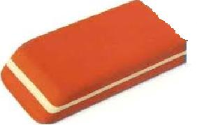 → those are ……………………… 5.-…………. is this ? - It …. a…………………………………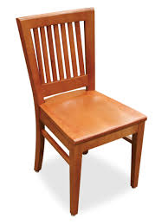 6.What ………. these ?- ………………………………………………. 7.What …… that?- It’s a………………………………………… 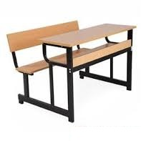 8.-what…………those ?- they are………………………………….…… 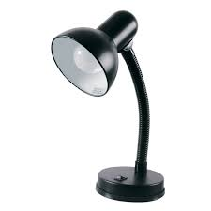 9.What……. these?- they’re …………………………………….…….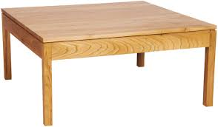
Ex14.Gạch chân lỗi sai và sửa lại. 1.Is this a pen? Yes they is →____________ 2. Is those lamps ? No they aren’t →__________ 3. Are these your pens? Yes it are →__________ 4. Are those your desk ? yes they are →__________ 5. Those are your glues? Yes they are →__________ 6. Are that desks ? No they aren’t→_________ 7. Are these your chalks ? Yes they is →_________ 8. Are this rulers ?yes they are not→______
Ex15.Câu đúng đánh dấu √ câu sai đánh dấu × 1. This is a pen. _______ 2. That is a ruler. _______ 3. This is a bag. _______ 4. That isn’t a board. _______
Ex16.Gạch chân lỗi sai và sửa lại. 1.this is an pen→__a__ 2. that isn’t a lamps →______ 3. Is this a chalk? No it is →___________ 4. What are this? It’s a pencil →____________ 5. That is a eraser →___________ 6. Are that a chair? No it isn’t →___________ 7.That isn’t not a bag →____________ 8. What Is that a pen ? yes it is →_____________ 9.That is a bag? Yes it is →____________ 10. Is this a ruler ? yes it is not→_____________
Ex17.Khoanh phương án đúng:
3.what(is / are) those? -(it / they / this) are balls. 8.is that (a / an) old man? - yes (it / that / he) is.
4.(Is / Are ) these your sons? - no (it / they) aren’t. 9.Are these (a / an / her )beds?- (yes / no) they are
5.Is this (a / an / the) desk ? - no it (is / isn’t) 10.are those( a / an / her ) trains? -(yes / no) they aren’t

