[**ENGLISH 4**](https://vndoc.com/tieng-anh-lop-4) – HK1

# Unit 1

## Translate to English:

* Chào buổi sáng:
* Chào buổi trưa/ chiều:
* Chào buổi tối:
* Chào tạm biệt:
* Chúc ngủ ngon:
* Rất vui khi được gặp bạn:
* Hẹn mai gặp lại:
* Hẹn gặp bạn lần sau:

## Put the words in order:

1. to/ see/ nice/ you/ again

-

1. tomorrow/ you/ see

-

1. are/ how/ you?

-

1. very/ thanks/ well,/ I’m

-

# Unit 2

* Dùng **“am”** khi chủ từ là: **“is”** khi chủ từ là: **“are”** khi chủ từ là:

## Read and write:

1. Where are you ?

* I am from Viet Nam.

1. Where… you from?

* I… from England.

1. is Tim from?

* He… from Australia.

1. Where Mary from?

* ……..is from America.

1. Where Tony and Susan from?

* ……..are from Japan.

1. What nationality you?

* I’m American.

1. nationality are you?

* I am English.

1. What nationality Tony?

* He… Japanese.

1. What nationality Susan?

* ……..is Australian.

1. What nationality Hoa and Quan?

* ……..are Vietnamese.

1. I’m from Viet Nam. I’m…….. .
2. Tony is from He’s English.
3. Mary is from Malaysia. She is…….. .
4. Linda and Tom are from They are American.
5. Peter and Donny are from They are Australian.

# Unit 3

* Khi đầu câu là **“he/ she/ it (số ít)”** thì động từ thêm:
* Thêm **“-es”** khi động từ tận cùng là:

## Translate to English:

* Thứ hai:
* Thứ ba:
* Thứ tư:
* Thứ năm:
* Thứ sáu:
* Thứ bảy:
* Chủ nhật:

## Answer the questions:

1. What day is it today? (Monday)

- It’s …….. ..................................

1. What day is it today? (Wednesday)

- …….............................................

1. What day is it today? (Friday)

- ……..…….............................................

1. What do you do on Mondays? (go to school)

- ……..…….............................................

1. What does Hoa do on Saturdays? (watch TV)

- ……..…….............................................

1. What do Nam and Tom do on Tuesdays? (watch TV)

- ……..…….............................................

1. What does Peter do on Fridays? (go swimming)

- ……..…….............................................

1. What does Tony do on Sundays? (help my parents)

- ……..…….............................................

1. What does Linda do on Thursdays? (visit my grandparents)

- ……..…….............................................

1. What do Quan and Lan do on Sundays? (visit my friends)

- ……..…….............................................

# Unit 4

## Translate to English:

|  |  |
| --- | --- |
| - Tháng 1: | - Tháng 7: |
| - Tháng 2: | - Tháng 8: |
| - Tháng 3: | - Tháng 9: |
| - Tháng 4: | - Tháng 10: |
| - Tháng 5: | - Tháng 11: |
| - Tháng 6: | - Tháng 12: |

* ***Answer the questions:***

1. What is the date today? (1/1)

- It’s ……..…….............................................

1. What is the date today? (2/9)

- ……..……..................................................

1. What is the date today? (3/12)

- ……..……..................................................

1. When’s your birthday? (12/10)

- ……..…….................................................

1. When is your father’s birthday? (9/5)

- ……..…….................................................

1. When is your mother’s birthday? (19/8)

- ……..…….............................................

1. When’s your brother’s birthday? (20/7)

- ……..…….............................................

1. When’s your sister’s birthday? (23/4)

- ……..…….............................................

1. When is your grandfather’s birthday? (15/6)

- ……..…….............................................

1. When is your grandmother’s birthday? (29/11)

- ……..…….............................................

# Unit 5

* Sau **“can/ can’t”** thì động từ:

## Answer the questions:

1. What can you do? (cook)

- ……..…….............................................

1. What can you do? (sing)

- ……..…….............................................

1. What can Linda do? (dance)

- ……..…….............................................

1. What can Tom do? (swim)

- ……..…….............................................

1. What can Donny and Tony do? (play volleyball)

- ……..…….............................................

1. Can you cycle? (yes)

- ……..…….............................................

1. Can you play table tennis? (no)

- ……..…….............................................

1. Can Hoa play the piano? (yes)

- ……..…….............................................

1. Can Tony play the guitar? (no)

- ……..…….............................................

1. Can Quan and Mary play chess?

- ……..…….............................................

|  |  |  |  |  |  |
| --- | --- | --- | --- | --- | --- |
| zoo | apple | Literature | hospital | grapes | English |
| mango | Math | bank | banana | History | airport |

# Read and match.

|  |  |  |  |  |
| --- | --- | --- | --- | --- |
| 1. | When do you have English? | a. | No, she doesn’t. | 1 _ |
| 2. | Does she have milkshake? | b. | I like balloons. | 2 _ |
| 3. | Where’s your bed? | c. | We have it on Saturday. | 3 _ |
| 4. | Where does she work? | d. | She works in a hospital. | 4 _ |
| 5. | What do you like? | e. | It’s in my bedroom. | 5 _ |

1. **Re-arrange the words.**

|  |  |
| --- | --- |
| 1. | the/ is/ computer/ This/ new/. |
|  |  |
| 2. | you/ Do/ noodles/ have/? |
|  |  |
| 3. | English/ have/ we/ Monday/ on/ ?/ Do |
|  |  |
| 4. | time/ is/ it/ What? |
|  |  |
| 5. | balloons/ doesn’t/ He/ like/. |
|  |  |

1. **Read and fill in the correct circle.**

My name’s Anh. This is my classroom.

The tables are long. There’s a big board and there are two computers. There are big posters on the wall. There are pictures, too. Can you see my picture? It’s a picture of my family. My teacher is Miss Tam. I like her.

|  |  |  |  |  |  |
| --- | --- | --- | --- | --- | --- |
| 1. | The girl’s name is_ . | | 2. | There are posters on the . | |
| A. | Lan | ○ | A. | wall | ○ |
| B. | Anh | ○ | B. | computer | ○ |
| C. | Kim | ○ | C. | tables | ○ |
| 3. | The tables are _. | | 4. | The teacher’s name is . | |
| A. | long | ○ | A. | Miss Anh | ○ |
| B. | short | ○ | B. | Miss Nam | ○ |
| C. | tall | ○ | C. | Miss Tam | ○ |

# Look at the pictures and write: That is This is these are Those are This is

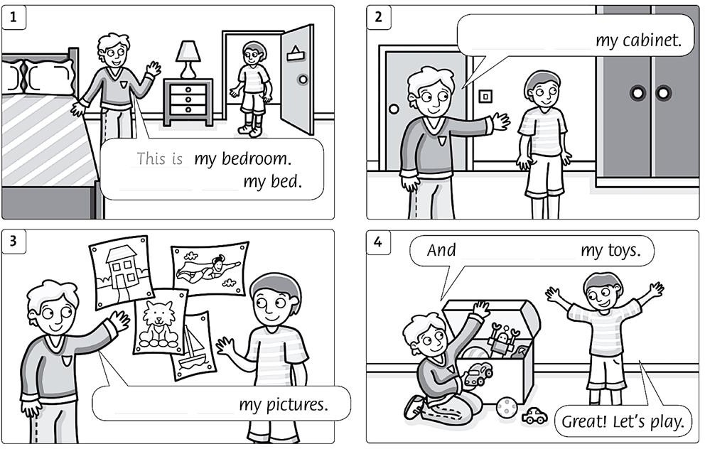

1. **Match**
2. How many cabinets are there? a. No, sorry. We don’t have it now. 1,
3. Do you have noodles? b. There are two. 2,
4. Does the boy have black hair? c.I go to school. 3,
5. When do you go to bed? d. Yes, he does. 4,
6. Where do you go? e. I go to bed at nine o’clock. 5,

# Order the words.

1. my/ This/ favorite/ is/ dress/ purple/.
2. on/ wall/ the/ There/ big/ posters/ are/.
3. Saturday/ We/ don’t/ have/ on/ school/.
4. flowers/ likes/ Linh/.

____________________________________________________

1. Mrs./ Our/ Loan/ teacher/ is/.

# Read and answer the questions.

At our school we have two big school yards. This is my school yard. It is for the 1st, 2nd, and 3rd, grade students. The 4th and 5th grade students play in a different school yard.

There are squares on the school yard where we can play games. The students can play with a ball and run around. We can also talk to our friends. We love our school yard.

1. How many school yards are there?
2. What shapes are on the school yard?
3. What can they play?
4. Who can they talk to?

# Write.

What Where’s When What’s When

1. your name? My name is Khang.
2. his teddy bear? His teddy bear is in his bedroom.
3. do you have P.E? On Tuesday.
4. does she like? She likes candy.
5. does she get up? She gets up at eight o’clock.
6. **I. LISTENING**

**1. Listen and number**

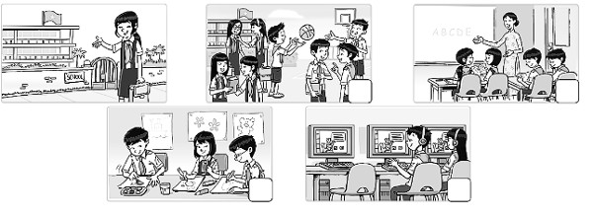

**2. Listen and draw lines.**

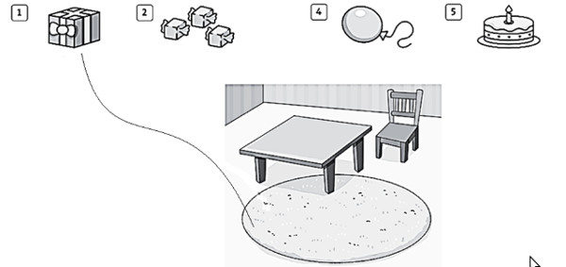

**II. Read the words. Write them in the correct boxes.**

|  |  |  |  |  |  |
| --- | --- | --- | --- | --- | --- |
| zoo | apple | Literature | hospital | grapes | English |
| mango | Math | bank | banana | History | airport |

|  |  |  |
| --- | --- | --- |
| **subjects** | **fruits** | **places** |
| _______________ | _______________ | _______________ |
| _______________ | _______________ | _______________ |
| _______________ | _______________ | _______________ |
| _______________ | _______________ | _______________ |

**III. Read and match.**

|  |  |  |  |  |
| --- | --- | --- | --- | --- |
| 1. | When do you have English? | a. | No, she doesn’t. | 1________ |
| 2. | Does she have milkshake? | b. | I like balloons. | 2________ |
| 3. | Where’s your bed? | c. | We have it on Saturday. | 3________ |
| 4. | Where does she work? | d. | She works in a hospital. | 4________ |
| 5. | What do you like? | e. | It’s in my bedroom. | 5________ |

**IV.** **Re-arrange the words.**

1. the/ is/ computer/ This/ new/.

___________________________________________________________

2. you/ Do/ noodles/ have/?

___________________________________________________________

3. English/ have/ we/ Monday/ on/ ? / Do

___________________________________________________________

4. time/ is/ it/ What?

___________________________________________________________

5. balloons/ doesn’t/ He/ like/.

___________________________________________________________

**V. Read and fill in the correct circle.**

My name’s Anh. This is my classroom.

The tables are long. There’s a big board and there are two computers. There are big posters on the wall. There are pictures, too. Can you see my picture? It’s a picture of my family. My teacher is Miss Tam. I like her.

1. The girl’s name is________.

A. Lan

B. Anh

C. Kim

2. There are posters on the _________.

A. wall

B. computer

C. tables

3. The tables are ________.

A. long

B. short

C. tall

4. The teacher’s name is _________.

A. Miss Anh

B. Miss Nam

C. Miss Tam

**VI. Look at the pictures and write.**

**That is       This is      these are       Those are       This is**

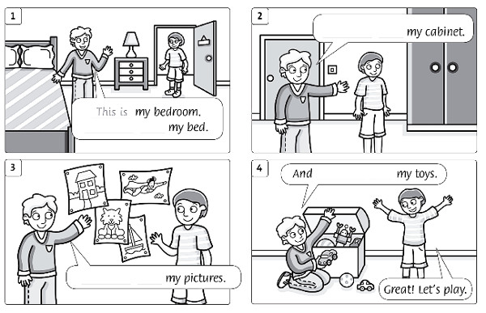

***I/ Choose the best answer ( Chọn đáp án đúng nhất ) : ( 2 ms )***

1/ …………….. are you from ?

A/ When B/ Where C/ Who

2/ His birthday is ………………… December.

A/ in B/ on C/ at

3/ She is happy ……………. Today is her birthday.

A/ but B/ and C/ because

4/ Would you like a ………………………….?

A/ banana B/ apple C/ ice cream

5/ I can speak ………………………

A/ Vietnam B/ England C/ English

6/ ………………..subjects do you like ?

A. What B. Who C. How

7/ Do you………………Math today ?

A. sing B. have C. draw

8/ There………….twenty students in my class

A. have B. is C. are

***II/ Fill in the blanks with suitable letters (Điền vào chỗ trống chữ cái thích hợp) ( 2 ms)***

1/ He can r_ _ d English books.

2 / My b _ _ thday is in March.

3 / I have Inf _ r m _ tics and Art today.

4/ There are four bo_ _ s on the table.

***III. Reorder the words to make sentences:(Sắp xếp trật tự các từ để có câu hoàn chỉnh ) (2mss)***

1/ our / classroom / is / This

…………………………………………………………….

2/ like / you / milk / Would / some ?

………………………………………………………………………………

3/ pencils / many / How / are / there ?

………………………………………………………………………………

4/ you / What / have/ subjects / today / do / ?

………………………………………………………………………………

***IV/ Fill in the blanks with suitable prepositions ( Điền vào chỗ trống với giới từ thích hợp ) ( 2ms)***

1/ During English lessons we learn to read and write ……………… English.

2/ This gift is …………………… you .

3/ I’m ……………. Viet Nam.

4/ Nam learns …………………speak English.

***V/ Read the passage carefully and answer the questions***

***( Đọc đoạn văn trả lời câu hỏi ) ( 2 ms)***

Trang is a student at Vinh Binh Primary School. There are thirty students in her class. Today she has Maths , English ,Music and Science. She likes English the most because she wants to be an English teacher. She does not go to school on Saturday and Sunday.

1/ Is Trang a student at Vinh Binh Primary School?

2/ How many students are there in her class?

3/ What subjects does she have today?

4/ Why does she like English?

